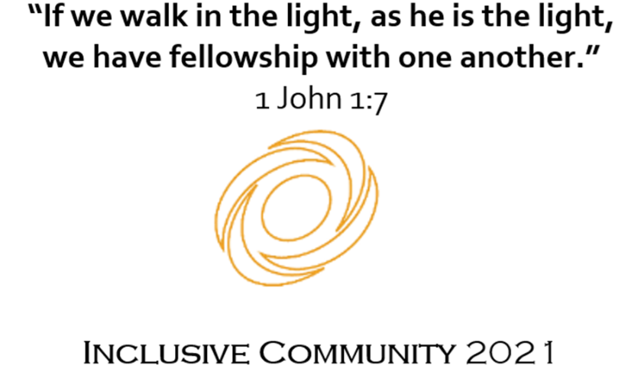

**St Edmund’s Mass times- Term 1**

Thursday 8.20am in the Chapel, please sign in at reception.

Everyone is most welcome.

Week 1- 4th February

Week 2- 11th February

Week 3- No Mass (Camp Week)

Week 4- 25th February

Week 5- 4th March

Week 6- 11th March

Week 7- 18th March

Week 8- 25th March

Week 9- 1st April

