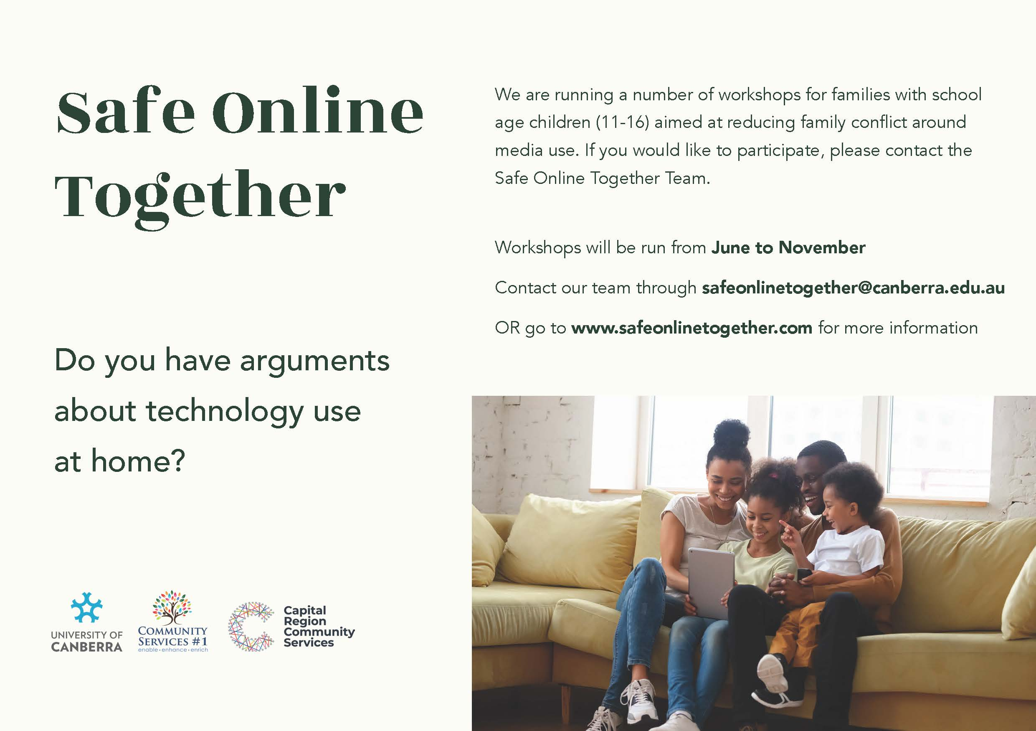

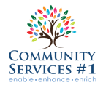
St Edmund's College - Safe Online Together
Reducing conflict within families around media and technology use
Is device and technology use a source of conflict in your household?
Are you concerned about your children’s use of technology, but struggle to manage it?
Researchers from the University of Canberra, in partnership with Community Services #1 and Capital Region Community Services, are holding a series of workshops with families to help them navigate and manage media and technology use at home.
Is this another cyber safety presentation?
No. Rather than focusing primarily on risk, workshops are aimed at promoting mutual understanding of media use between parents and their children, to help families negotiate media use and reduce conflict. We aim to help families maximise the benefits of digital media technologies while minimising the risks.
Who can attend?
Workshops are aimed at families with at least one child aged between approximately 11-16. While the entire family does not need to attend (but are welcome to!), workshops are designed for parent/s and their child/ren together.
When will they be happening?
A series of workshops will be held from June until November 2021. Several workshops are being held at schools, including St Edmund's College. Visit safeonlinetogether.com for more information. St Edmund's College are hosting Family Workshops on Tuesday 17 August and Tuesday 24 August (if interest dictates).
Is there a cost?
No – the workshops are free, and we will provide pizza and refreshments.
Can I tell others about the workshops?
Yes!
Is this a research project?
While our primary goal is to help families, data generated from the workshops will be collected to evaluate the project and inform ongoing research and future initiatives. While some of this data may be published in scholarly journals, all data will be anonymised to protect the privacy of participants. The project has been approved by the University of Canberra Human Research Ethics Committee.
How do I sign up?
You can sign up through: www.eventbrite.com.au/e/safe-onlie-together-family-workshop-1-tickets-165848755091
More information about the project can be found at safeonlinetogether.com

Safe Online Together

Overview of School Presentations and Family Workshops

School Presentations

St Edmund’s College will have the following School Presentations (student workshops). There is no need for students to register interest or sign up for these.

Student Workshops

Wednesday 11 August – 9.45am-10.37am. Year 5 students. Waterford and ERC.
Wednesday 11 August – 11.20am – 12.10pm. Year 6 students. Waterford and ERC.

Friday 13 August – 9.45am-10.37am. Year 7 Hall and Waterford (3 Houses each)
Friday 13 August – 11.20am – 12.10pm. Year 8 students in Hall and Waterford (3 Houses each).

The school presentations, which will be delivered to year groups (between Years 5 – 8) have been designed with age-appropriate content and to address issues that have been raised within school communities. Under the overarching theme of ‘digital citizenship’ we will cover two main areas: media balance and wellbeing, and relationships and respectful communication. While not avoiding the conversations about online risks, the focus is more on how we use technology in a way that is responsible, respectful and appropriate.
Students in Years 5,6 & 7 will participate in a number of activities including, for example:
- Discussion about all the different ways we use technologies and what the benefits are.
- Complete a quiz (online Kahoot or offline).
- Watch a short video about media balance and making healthy media choices followed by pair and group discussion.
- Topic discussion about one of the following:
  - digital drama and how to deal with it
  - digital friendships and how to keep online friendships safe
  - chatting safely online
  - how does social media affect our relationships?
- Discussion about what kinds of things spark arguments at home about technology use and what they think their parents worry about.
Students in Years 8 will participate in the following activities:
- Discussions about:
  - Why media balance is important and how to create a healthy media balance
  - Setting their own guidelines for media use and how to manage it
  - Developing their own strategies
- Complete a quiz around media balance
- Watch a short video about friendships and social media followed by pair and group discussion.
- Topic discussion about one of the following:
  - Digital footprints
  - Benefits and drawbacks of social media
  - Risks and potential consequences of sexting
  - Chatting and red flags
  - Rewarding relationships – healthy and positive

Family Workshops

St Edmund’s College will have the following Family Workshops:

Family Workshops

Tuesday 17 August – 6pm-8pm in Edmund Rice Centre.
Tuesday 24 August – 6pm-8pm in Edmund Rice Centre (if required).

The family workshops are designed to facilitate understanding between young people and their parents around technology use and ultimately to reduce it as a source of tension at home. The workshops have been designed to be engaging and fun for participants with the goal of facilitating conversations between parents and their children.
Activities include:
- An icebreaker online quiz which families will do together designed to highlight the different technology-related knowledges and practices between the generations.
- The group will break up into two: parents in one group and young people in the other.
  - Each group will be asked to think about all the different devices they use in the home and the way they use them. The young people will be asked to think about why it is so important for them to have technology and why their parents might be worried about them. The parents will be asked to come up with a consolidated list of their main concerns.
- Small groups will be given different story stems which present different scenarios related to digital media technologies. These story stems will cover a range of issues including respectful relationships, bullying and unwanted contact, and will be selected based on the outputs of Activity 2 and adapted from resources provided by the Office of the eSafety Commissioner. Participants are asked to finish the stories and share them with the group. Group discussion will follow about online risks, how these risks can be managed, and where participants can go for more information.
- In separate groups, parents and young people will compile a list of the main sources of technology-related conflict at home. Taking the top three issues, the group will then discuss possible strategies to resolve some of these conflicts.
Participants will be asked to participate in a short feedback exercise (if time) or to fill in an evaluation survey. There will be handouts available for participants to take home including templates of family technology agreements and further information about additional resources. Participants will also be invited to take part in a follow up conversation (interview or focus group) to seek feedback on how useful they found the workshop.
Data from the workshops will be collected to inform ongoing research and initiatives in this area. As such, participants will be asked to sign a consent form, however participants can opt out of having their data collected. All data will be anonymised to protect the privacy of participants.

